Unit 1 Homework: Write-up

1. **Given the provided data, what are three conclusions we can draw about Kickstarter campaigns?**
2. Outside of two categories, the success rate of most startups does not go beyond 50%, and the primary success occurs in artistic categories (as opposed to business related fields).

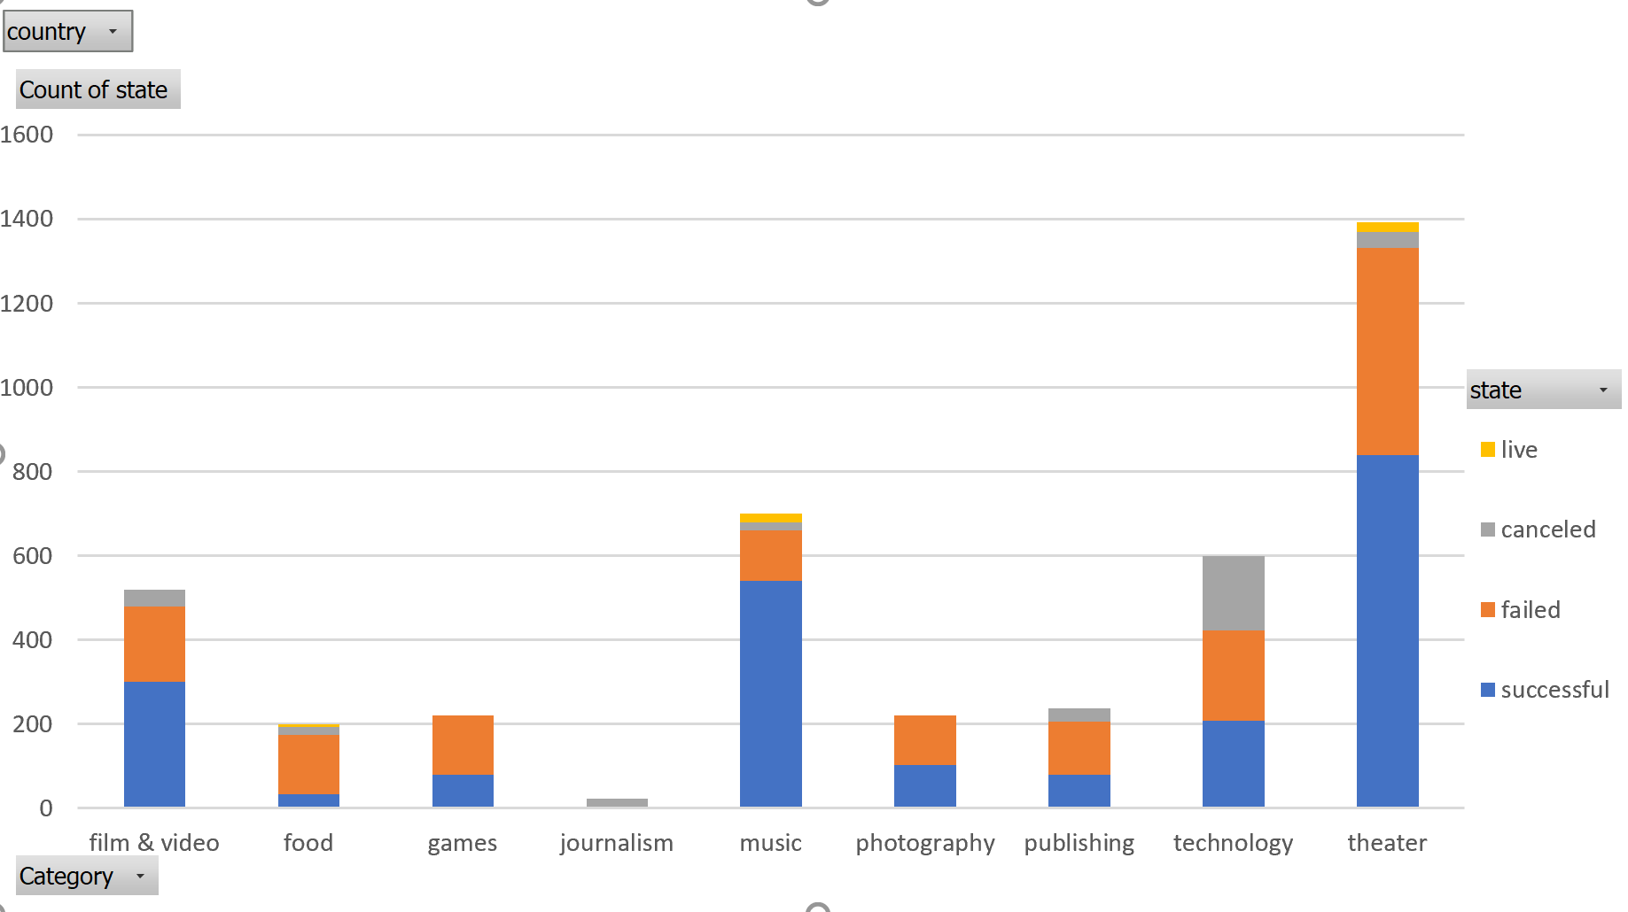

1. Plays make up the majority of successful kick starter, and contribute the most as to why the arts genre of kick starters succeeds the most.

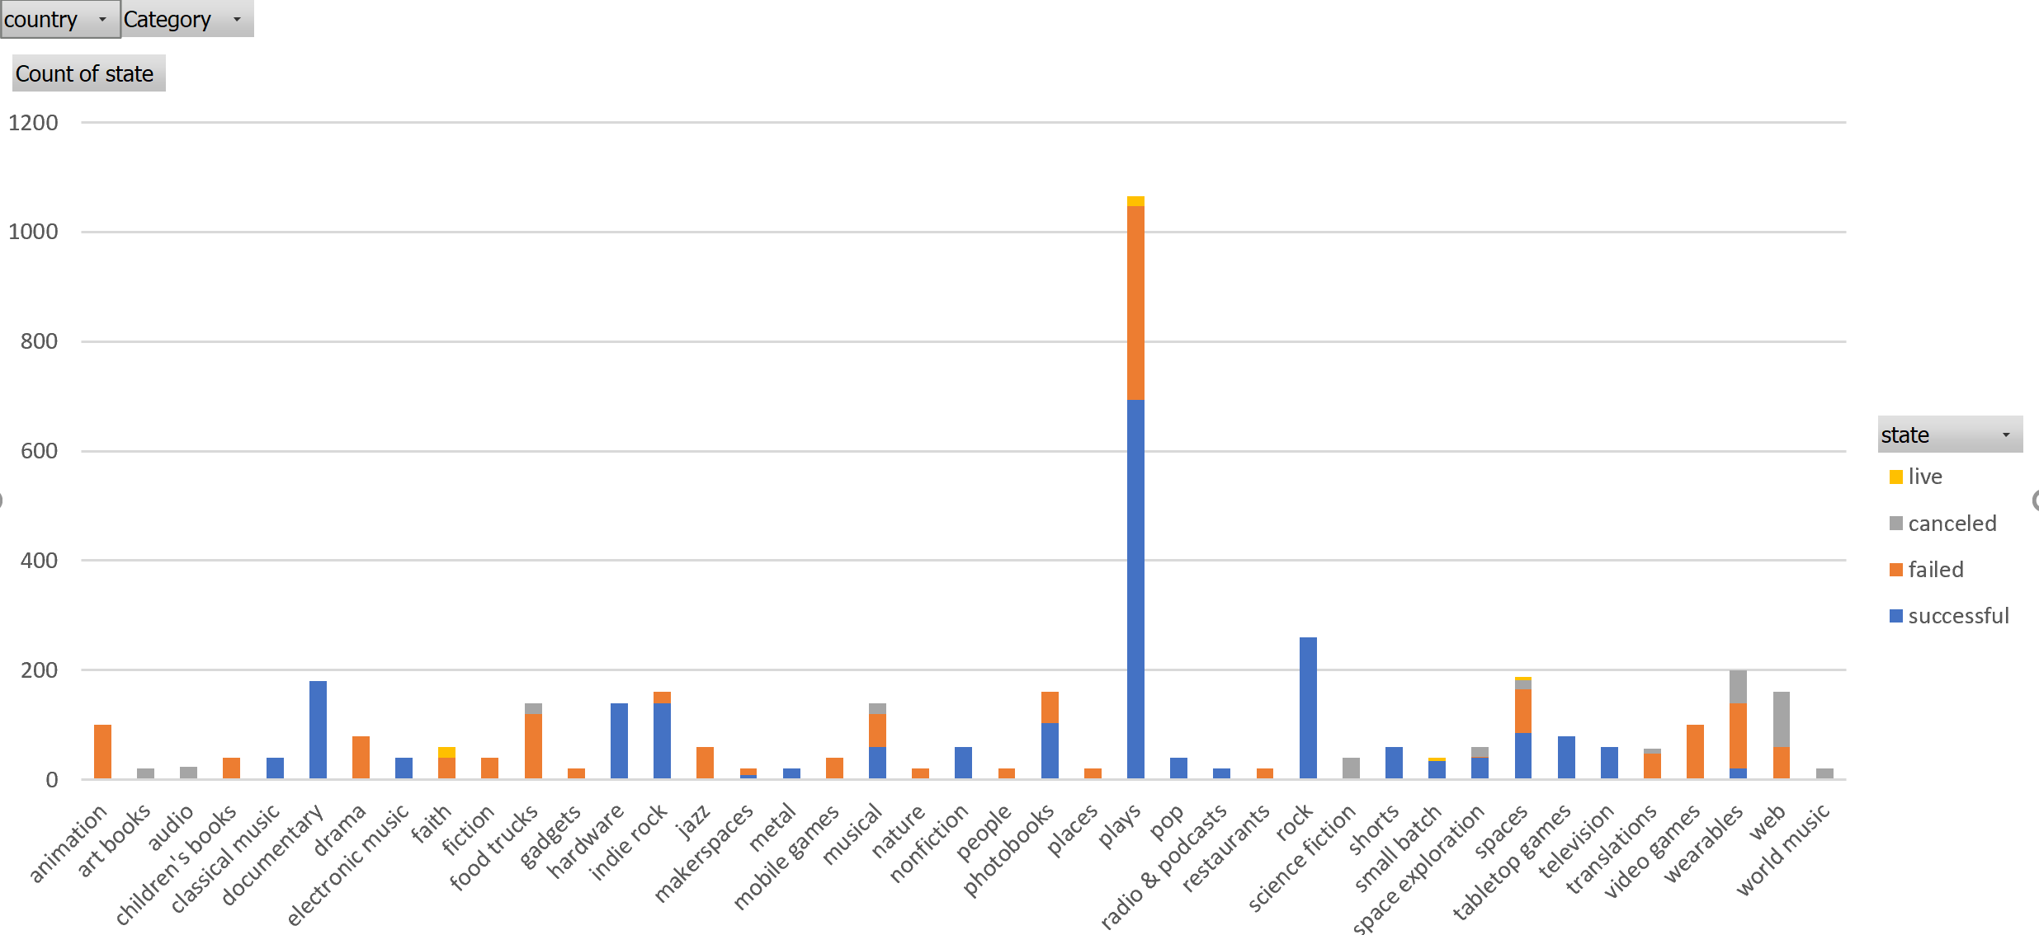

1. Kick starter campaigns seem to generally have high success rate in the first half of the year over the latter half of the year. This can be seen across the bigger categories as there is a huge gap between the number of successful Kickstarters versus failed and canceled ones—when those time periods are somewhere in the first half of the year. This can be seen in the following success over time for film/video, theater, music, and technology (respectively)

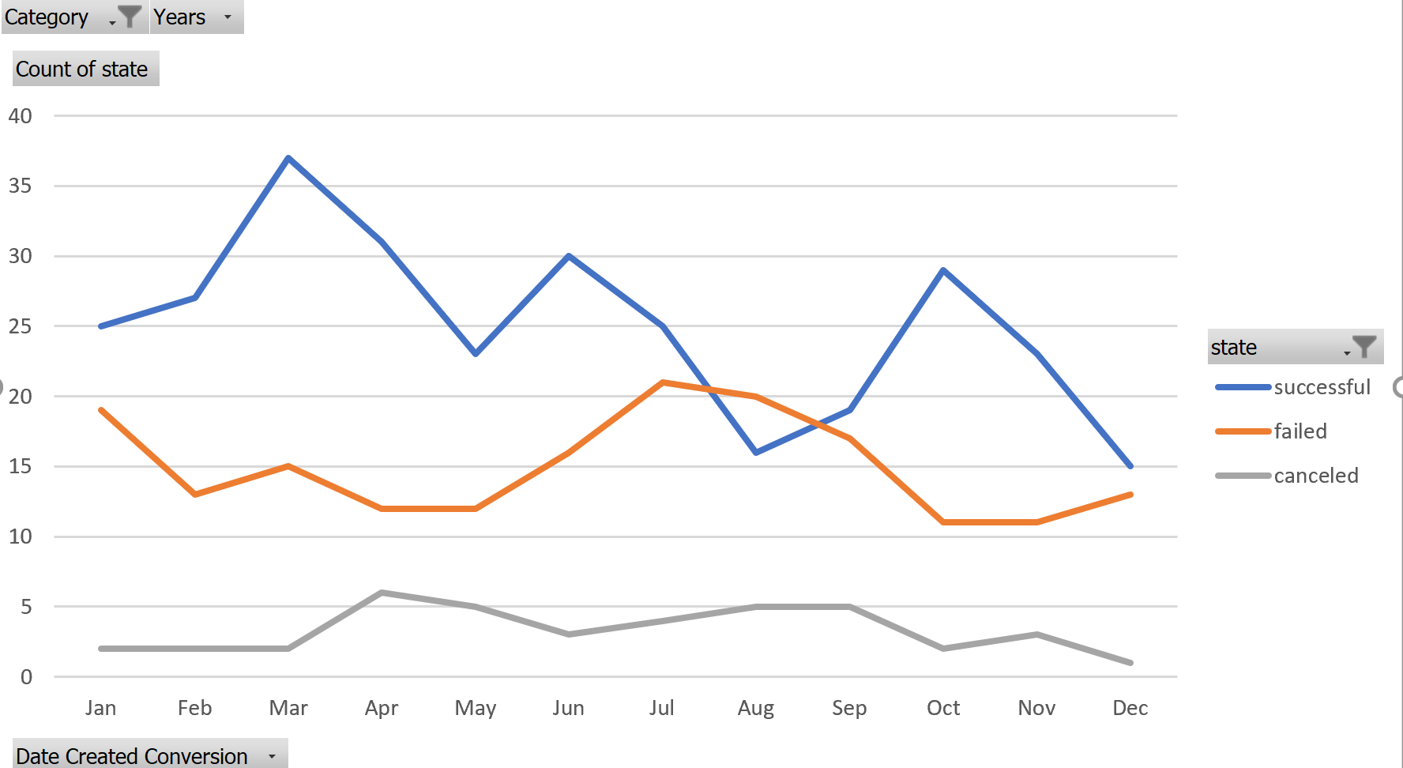

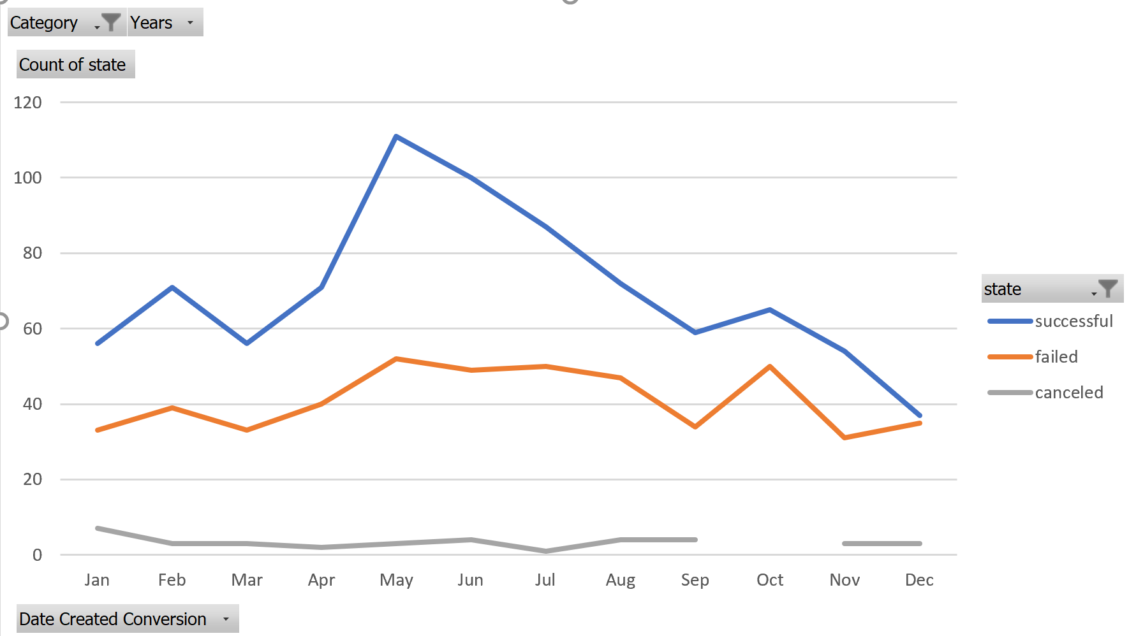

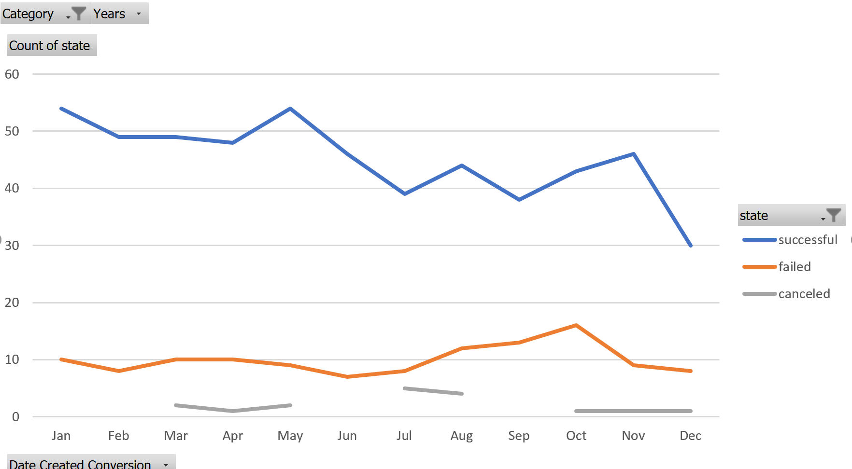

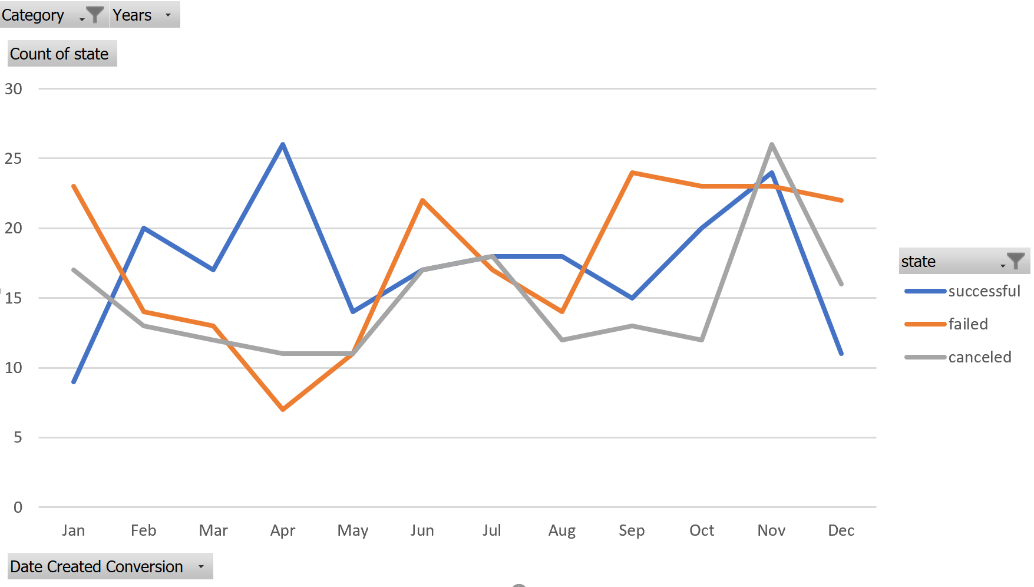

1. **What are some limitations of this dataset?**

Kickstarter campaigns involve the donations of the backers—which in turn relies on how well the creators can entice their backers into the success of their project. The only insight through this data set that we have for this attempt to convince people is the “blurb” description. This gives us little insight into the “effort” a company put into its Kickstarter.

On top of that, Kickstarter backers usually will get a reward based on how much they donate to the said Kickstarter. We have no information on what dollar values these pledge values start—perhaps when Kickstarter programs require lower dollar amounts to get a reward, they will be more successful.

Finally, there is no breakdown of the backers’ donation amounts. This does not allow us to see whether these total donations are top heavy (i.e. successful due to the funds of a few wealthier backers) or whether they involved a stronger group effort. Perhaps the arts category has more top heavy donators than the games.

1. **What are some other possible tables and/or graphs that we could create?**

We can create a table that breaks down average backer donation via category and subcategory.

Another table we can make is one that could give us a count of the staff picks across each of the successful, failed, and cancelled Kickstarters. This can allow us to analyze how influential the staff picks are in helping a Kickstarter succeed.

Finally, we can make pie charts that we derive from tables that count the number of successful Kickstarters per category, the number of failed, and the number of cancelled. Each of these can a more clear idea of which categories dominate the successful Kickstarters vs the failed Kickstarters.